Love Your Market Town Grant Fund 2026/27

Expression of Interest (EOI)

Name of Business or Organisation

Address of proposed project

Name of main contact

Contact telephone number

Contact email

What type of organisation are you?
(for example: Business, Community Group, Charity, Parish/Town Council).

Project name

Please describe your proposed project.

What will the project achieve for your town?

Estimated total project costs | £
Estimated grant requested (between £1,000 and £5,000) | £
Proposed project start date

Proposed project end date

How will your project achieve a long-lasting sustainable impact on the town?

How will the project be funded as the Love Your Market Town grant is paid in arrears?

Anything else relevant to your project you think we should know.

 |  | 
 |  | 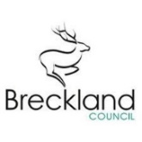 | 

